**MILESTONE 2**



**Spring 2025**

**CSE-403L Database Management System Lab**

Submitted by: **Ayesha Fayyaz (2123)**

**Noor ul Huda (2117)**

**Uswa Asad (2131)**

**Aleshba Aaina (2202)**

Semester: **6th**

Section: **B**

“On my honor, as student of University of Engineering and Technology, I have neither given nor received unauthorized assistance on this academic work.”

Submitted to:

**Engr. Sumayyea Salahuddin**

(May 27, 2025)

Department of Computer Systems Engineering

University of Engineering and Technology, Peshawar

# RELATIONAL SCHEMA

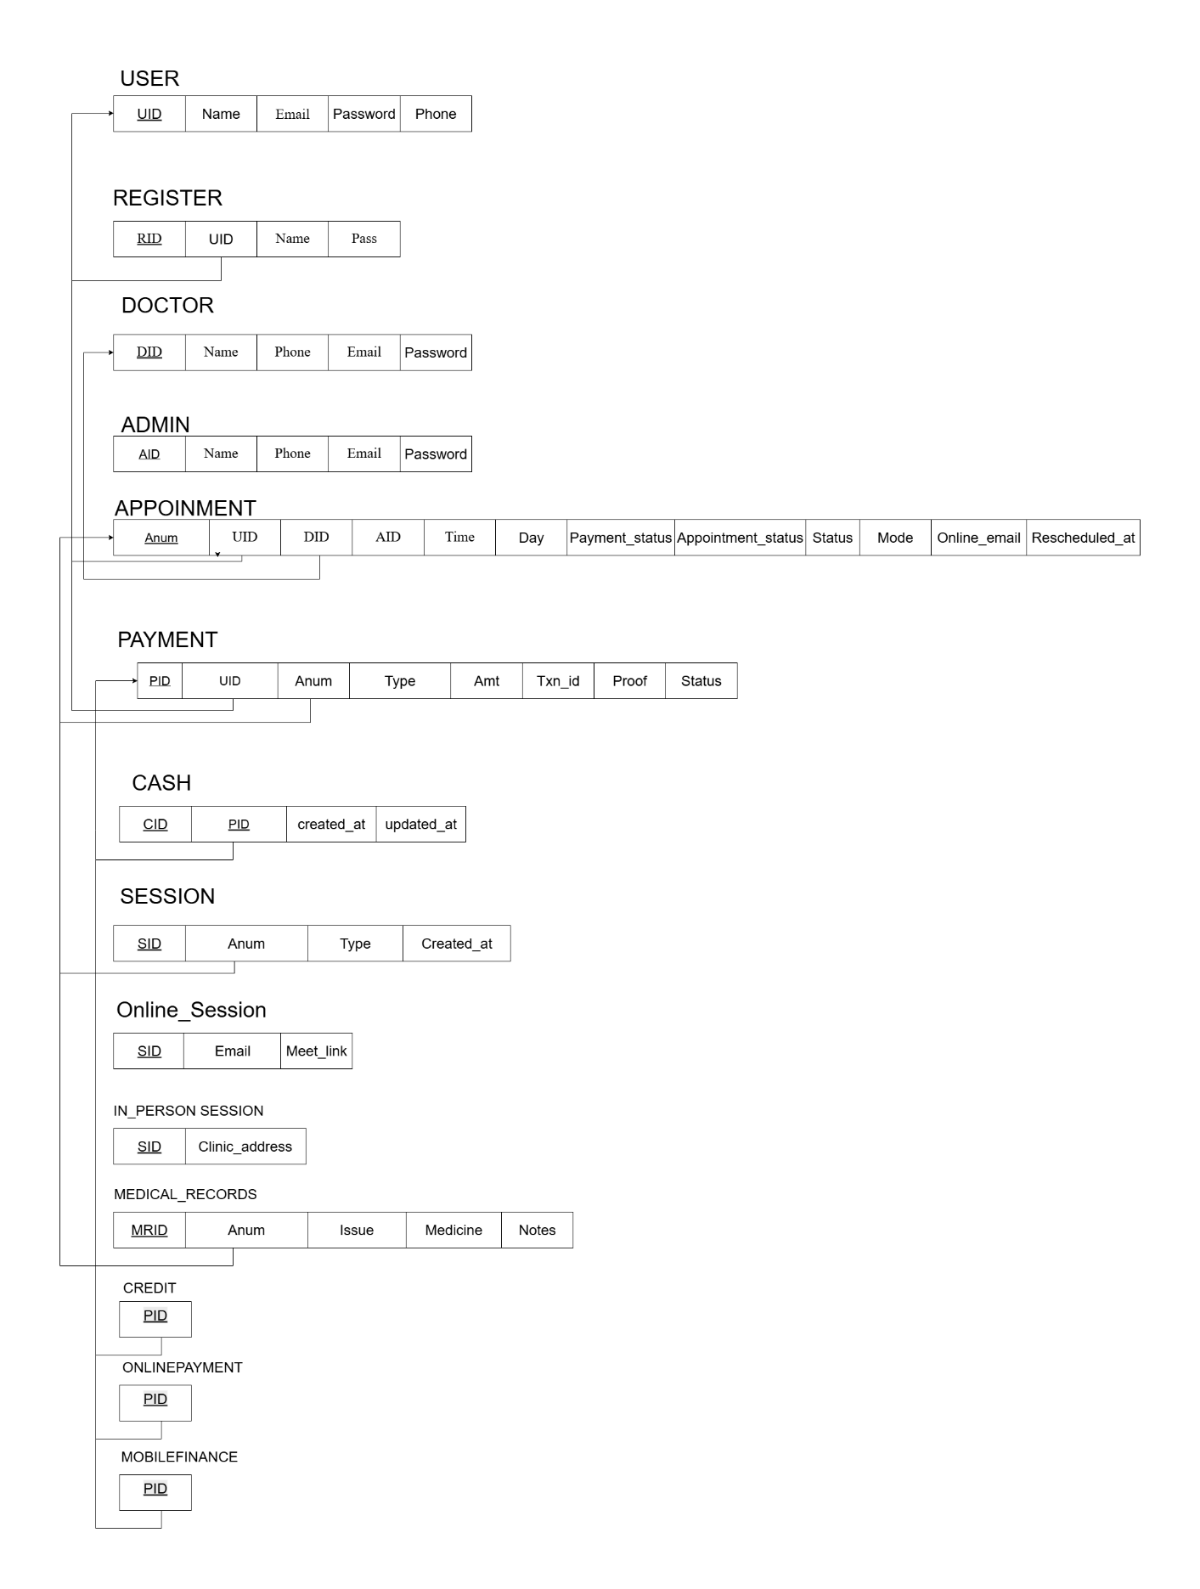

# Normalization

**1. USER (UID, name, email, password)**

* **1NF**: All attributes are atomic.
* **2NF**: All non-key attributes (email, password) depend fully on the primary key UID.
* **3NF**: No transitive dependencies.  
  **In 3NF**

**2. REGISTER (RID, UID, name, email, pass, phone)**

* **1NF**: Atomic values.
* **2NF**: Each attribute depends entirely on RID.
* **3NF**: No transitive dependencies between non-key fields.  
  **In 3NF**

**3. DOCTOR (DID, name, phone, email, password)**

* **1NF**: All values are atomic.
* **2NF**: All attributes depend on DID.
* **3NF**: No indirect (transitive) dependencies.  
  **In 3NF**

**4. ADMIN (AID, name, phone, email, password)**

* **1NF**: Attributes are atomic.
* **2NF**: Fully dependent on AID.
* **3NF**: No transitive dependencies.  
  **In 3NF**

**5. APPOINTMENT (Anum, UID, DID, AID, time, day, payment_status, appointment_status, status, mode, online_email, rescheduled_at)**

* **1NF**: Atomic values.
* **2NF**: All attributes depend entirely on Anum.
* **3NF**: UID, DID, and AID are foreign keys; no transitive dependency.

**In 3NF**

**6. SESSION (SID, Anum, type, created_at)**

* **1NF**: No repeating groups.
* **2NF**: All attributes depend on SID.
* **3NF**: Anum is a foreign key but no transitive dependencies.  
  **In 3NF**

**7. ONLINE_SESSION (SID, email, meet_link)**

* **1NF**: Atomic values.
* **2NF**: All attributes fully depend on SID.
* **3NF**: No transitive dependencies.  
  **In 3NF**

**8. INPERSON_SESSION (SID, clinic_address)**

* **1NF**: No multivalued fields.
* **2NF**: clinic_address depends on SID.
* **3NF**: No indirect dependencies.  
  **In 3NF**

**9. MEDICAL_RECORDS (MRID, Anum, issue, medicine, notes, created_at, updated_at)**

* **1NF**: Fields are atomic.
* **2NF**: Fully dependent on MRID.
* **3NF**: Anum is a FK; no transitive dependencies.  
  **In 3NF**

**10. PAYMENT (PID, UID, Anum, type, Amt, txn_id, proof, status)**

* **1NF**: All fields are atomic.
* **2NF**: All fields depend on the PK PID.
* **3NF**: UID and Anum are foreign keys; no transitive dependencies.  
  **In 3NF**

**11. CASH (CID, PID)**

* **1NF**: Atomic.
* **2NF**: Attributes depend on CID.
* **3NF**: PID is a FK; no transitive dependencies.  
  **In 3NF**

**12. CREDIT (PID)**

* **1NF**: No repeating groups.
* **2NF**: Single attribute depends on PK.
* **3NF**: References payment.PID; no transitive dependency.  
  **In 3NF**

**13. ONLINEPAYMENT (PID)**

* **1NF**: Atomic.
* **2NF**: PID is PK and FK.
* **3NF**: No indirect dependencies.  
  **In 3NF**

**14. MOBILEFINANCE (PID)**

* **1NF**: Atomic.
* **2NF**: Single attribute depends on PK.
* **3NF**: FK to payment; valid normalization.  
  **In 3NF**